Midterm practice
STAT218
2026-06-13
The problems below are representative of the type and difficulty of questions you will encounter on the midterm. On the exam, quantitative results will be provided for you; prompts will ask you to interpret results in context or carry out simple follow-up calculations.

NHANES
The National Health and Nutrition Examination Survey (NHANES) is an ongoing program of studies designed to assess the health and nutritional status of adults and children in the United States. The first few rows of the dataset are shown below.
load('data/nhanes.RData')
head(nhanes)
# A tibble: 6 × 9
subj.id gender age poverty pulse bpsys1 bpdia1 totchol sleephrsnight
<int> <fct> <int> <dbl> <int> <int> <int> <dbl> <int>
1 1 male 34 1.36 70 114 88 3.49 4
2 2 male 34 1.36 70 114 88 3.49 4
3 3 male 34 1.36 70 114 88 3.49 4
4 5 female 49 1.91 86 118 82 6.7 8
5 8 female 45 5 62 106 62 5.82 8
6 9 female 45 5 62 106 62 5.82 8
- [L2] Is this an observational study or an experiment? Briefly explain your reasoning.
- [L3] Which variables in the dataset are numeric? For each, state whether it is discrete or continuous.
The histogram below shows the distribution of systolic blood pressure among respondents.
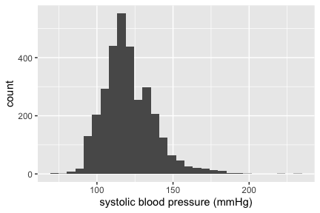
- [L3] Describe the distribution of systolic blood pressure. Comment on shape, center, spread, and any notable features.
The output below shows inference on mean resting pulse rate among U.S. adults.
t.test(nhanes$pulse, mu = 72)
One Sample t-test
data: nhanes$pulse
t = 2.8235, df = 3178, p-value = 0.00478
alternative hypothesis: true mean is not equal to 72
95 percent confidence interval:
72.18071 73.00205
sample estimates:
mean of x
72.59138
- [L3] How many observations are in the dataset? Explain how you determined this from the output.
- [L4] Interpret the 95% confidence interval for mean resting pulse in context following conventional style.
- [L5] Report the result of the test in context following conventional style. Use a 5% significance level.

Creativity and motivation
This problem uses data from an experiment on the effect of intrinsic vs. extrinsic motivation on creativity. A random sample of 47 creative writing students were randomly assigned to one of two groups. Each subject wrote two short poems under instructions that emphasized either external motivations for writing (e.g., recognition or reward) or internal motivations (e.g., self-expression or personal satisfaction). Poems were scored by judges for creativity on a 40-point scale. Scores by group are summarized in the boxplot below, followed by inference on the difference in means.
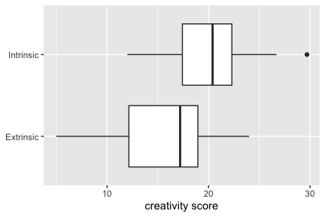
t.test(score ~ treatment, data = creativity, conf.level = 0.99)
Welch Two Sample t-test
data: score by treatment
t = -2.9153, df = 43.108, p-value = 0.005618
alternative hypothesis: true difference in means between group Extrinsic and group Intrinsic is not equal to 0
99 percent confidence interval:
-7.9749541 -0.3134517
sample estimates:
mean in group Extrinsic mean in group Intrinsic
15.73913 19.88333
- [L5] Based on the boxplots and the group sizes $n_{\text{Intrinsic}}=24$ and $n_{\text{Extrinsic}}=23$, do the assumptions for the inference shown seem plausible? Explain.
- [L5] Write the null and alternative hypotheses in statistical notation (in terms of $μ_{\text{Intrinsic}}$ and $μ_{\text{Extrinsic}}$).
- [L5] Report the result of the 1% level test following conventional style.
- [L4] Interpret the confidence interval for the difference in means in context following conventional style.
- [L4] Construct an approximate 95% confidence interval for the difference in means using the empirical rule.

Hippocampal volume
Studies have provided evidence that the hippocampus is smaller in schizophrenic patients on average. The dataset for this problem contains data on left hippocampal volume (in cm³) for pairs of monozygotic twins; one twin in each pair was affected by schizophrenia and the other was not. The output below shows inference on the mean difference (affected $−$ unaffected) in hippocampal volume within each pair.
load('data/hippocampus.RData')
t.test(hippocampus$affected - hippocampus$unaffected, mu = 0, alternative = 'less', conf.level = 0.99)
One Sample t-test
data: hippocampus$affected - hippocampus$unaffected
t = -3.2289, df = 14, p-value = 0.003031
alternative hypothesis: true mean is less than 0
99 percent confidence interval:
-Inf -0.03718909
sample estimates:
mean of x
-0.1986667
- [L5] Write the null and alternative hypotheses in statistical notation (in terms of the mean difference $δ$).
- [L5] How many pairs of twins were included in the study?
- [L5] Report the result of the test following conventional style. Use the significance level corresponding to the confidence level shown.
- [L4] Interpret the confidence interval in context following conventional style.
- [L5] Compute the standard error of the mean difference. Explain what this value quantifies.

Mussel physiology
Researchers recorded standardized anterior adductor muscle (AAM) scar length for Mytilus trossulus mussels sampled from five geographic populations. The objective of the study was to identify physiological differences among populations. A boxplot of the data and ANOVA model output are provided below.
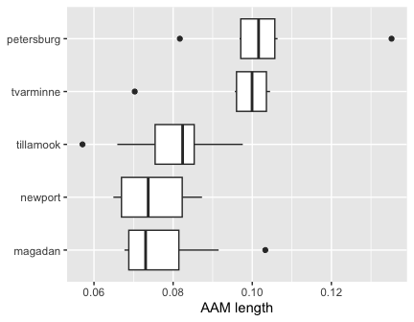
aov(aam.length ~ location, data = mussels)
Call:
aov(formula = aam.length ~ location, data = mussels)
Terms:
location Residuals
Sum of Squares 0.004519674 0.005394906
Deg. of Freedom 4 34
Residual standard error: 0.01259658
Estimated effects may be unbalanced
- [L9] How many mussels were measured in the study?
- [L9] Construct the ANOVA table. Show your work.
- [L9] Report the outcome of the omnibus $F$-test following conventional style. The $p$-value for the statistic you computed is less than 0.001. Assume a 5% significance level.
- [L9] Estimate the effect size $η^{2}$ and interpret it in context.

